Your name
Address 1
Address 2
Address 3
Postcode

Date:

CEO Name
Name of Government Agency
Address
Address 2
Address 3
Postcode

Dear Mr / Mrs ________
I am writing to you with regards to the Covid-19 vaccine, which is being heavily promoted by the Government, the NHS, and the mainstream media. It is concerning why there is so much censorship by our Governments and we are clearly no longer in a democracy if our thoughts are so threatening to a minority of people. What an absolute waste of taxpayers money that goes into the Government censorship network, including the National Security Council, GCHQ, Security Service MI5, Secret Intelligence Service MI6, Joint Biosecurity Centre, Cabinet Office, Rapid Response Unit, National Security Communications Team, 77th brigade, 13th signals, DCMS Fake News Unit, and the FOI Clearing House.
There are families pushed into poverty because of these cruel inhumane lockdowns and Governments just want to hold on to some degree of power and waste vast sums of taxpayers money, which they do not have. Government are not protecting people and punishing evil as they should. Neither are the Police and the Military Forces, which again is a waste of taxpayers money, because they are not upholding their oath of office, which is to hold Governments to account for corruption and fraud, and to protect the people. It could be Common Purpose training that has influenced their thought patterns. They are committing malfeasance in the public office, which is the intentional act of doing something legally or morally wrong. Covid-19 was downgraded on 19 March 2020 and is classified as no longer a high consequence infectious disease, and yet the first lockdown came into force several days later on 23 March 2020 by current Prime Minister, Boris Johnson. Tens of thousands of people have died because of the LOCKDOWNS. Many class action lawsuits have been started, and millions of people will be seeking remedy for these illegalities based on fraudulent science through the Drosden PCR test, which.
You are in an incredible position of power and I would remind you of your duty of care toward UK citizens, and to God as you are ordained by Him. Doctors and nurses are in those positions to hopefully save lives, and yet they are carrying out acts of nonfeasance in failing to provide the full truth about the vaccine, which is not technically a vaccine, but a technology, an mRNA technology, which the Government describes as biotechnological medicine in the introduction of its paper entitled: Consultation document: changes to Human Medicines Regulations to support the rollout of COVID-19 vaccines.
https://www.gov.uk/government/consultations/distributing-vaccines-and-treatments-for-covid-19-and-flu/consultation-document-changes-to-human-medicine-regulations-to-support-the-rollout-of-covid-19-vaccines
These ‘vaccines’ do not provide immunity in the traditional way that a vaccine works, so why are UK citizens being told a lie? This is purposeful malfeasance in the public office by all those who know what these ‘vaccines’ are as they know there is a high risk of adverse drug reactions, as the MHRA expected this and tendered for an Artificial Intelligence to report all Covid-19 adverse drug reactions, and doctors, nurses, and health professionals are committing the tort of nonfeasance in listening to only one side (The Government), when thousands of medical experts across the world have spoken of this vaccine’s potential dangers and been censored. Do you care for the UK citizens, or this just an act?
If you were not aware, malfeasance is criminal behaviour that carries with it a prison sentence, as is misfeasance in public office. To those administering the vaccine ignorantly and not providing the truth about the potential side effects and dangers before consent from the patient is given, failing to follow a care of duty to the general public carries with it the tort of nonfeasance, which results from negligence, breach of duty, causation, and injury and may result in remedy through a civil court.
What about doctors who have been putting Covid-19 on death certificates, when no autopsy has been carried out because roles like this were temporarily halted because of the Coronavirus Act 2020? It is malfeasance to label a death as something that was most likely an existing health condition.
https://soundcloud.com/onlyjesussaves/montana-physician-dr-annie-bukacek-discusses-how-cv-9teen-death-certificates-are-being-manipulated
https://assets.publishing.service.gov.uk/government/uploads/system/uploads/attachment_data/file/916035/RA_Technical_Summary_-_PHE_Data_Series_COVID_19_Deaths_20200812.pdf
The CDC have inflated data.
https://vaccineimpact.com/wp-content/uploads/sites/2/2021/02/CDC-Illegal-COVID-Deaths.pdf.
The UK Government are manipulating data through the PCR tests and still encouraging millions to get tested every week, and these lockdowns are illegal, and police enforcing these measures are acting out of their oath of office and committing nonfeasance in public office. It is their duty to actually check that the statistics and evidence is accurate, because they are fining people and businesses based on fraudulent science, contrary to what SAGE and its other departments states. They are only getting away with it because no one has held them to account for these injuries as of yet.
To ask doctors, nurses, and other health professionals to administer a biotechnological medicine (Covid-19 vaccine) to millions of UK citizens, without detailing to the patient of the possible Vaccine Adverse Drug Reactions that have occurred is committing the tort of nonfeasance. ‘I was just doing my job’ does not suffice when injuries are occurring, even death. Tell the truth. Stop lying.
- Pfizer vaccine (9 Dec 2020 – 24 Jan 21) – Total reactions for drugs 49,472 thus from, and 107 deaths
https://assets.publishing.service.gov.uk/government/uploads/system/uploads/attachment_data/file/958616/COVID-19_mRNA_Pfizer-_BioNTech_Vaccine_Analysis_Print.pdf
- Astra Zeneca (4 Jan 2021 – 24 Jan 2021) - Total reactions for drugs 21,032, and 34 deaths
https://assets.publishing.service.gov.uk/government/uploads/system/uploads/attachment_data/file/958615/COVID-19_AstraZeneca_Vaccine_Analysis_Print.pdf
- Vaccine brand unspecified (up to 24 Jan 2021) - Total reactions for drugs 189, and 2 deaths
https://assets.publishing.service.gov.uk/government/uploads/system/uploads/attachment_data/file/958617/COVID-19_vaccine_brand_unspecified_analysis_print.pdf
This Government paper states that every person must be made aware of what the vaccine is (ie, it is not a normal vaccine, but a biotechnological medicine), how it works (normal vaccines provide immunity from the disease, and these Covid-19 vaccines do not), and any possible side effects (even the risk of death), and yet because of the manipulation of the mainstream media and the hype toward the vaccine being the ‘cure all’, the tort of nonfeasance is being carried out by thousands of GPs, doctors, nurses, and health professionals, which is leading to genocide.
https://www.covidtruths.co.uk/wp-content/uploads/2021/02/Green-Book-Chapter-2-Consent-PDF-77K.pdf
https://assets.publishing.service.gov.uk/government/uploads/system/uploads/attachment_data/file/943646/Core_competency_assessment_tool_v3.pdf
This recent data from the Office of National Statistics show that there are no excess mortality rates for 2020, which would raise questions as to why we are told we are in a pandemic, but because they are an estimate let’s assume that the total number of deaths is just over 600,000.
* based on ONS estimates
Year | Registered Deaths | Number of Deaths
2020 | Deaths registered in England and Wales | 561,539*
2019 | Deaths registered in England and Wales | 530,841
2018 | Deaths registered in England and Wales | 541,589
2017 | Deaths registered in England and Wales | 533,253
2016 | Deaths registered in England and Wales | 525,048
2015 | Deaths registered in England and Wales | 529,655
2014 | Deaths registered in England and Wales | 501,424
2013 | Deaths registered in England and Wales | 506,790
2012 | Deaths registered in England and Wales | 499,331
2011 | Deaths registered in England and Wales | 484,367
2010 | Deaths registered in England and Wales | 493,342
2009 | Deaths registered in England and Wales | 491,348
2008 | Deaths registered in England and Wales | 509,090
2007 | Deaths registered in England and Wales | 504,052
2006 | Deaths registered in England and Wales | 502,599
2005 | Deaths registered in England and Wales | 512,993
2004 | Deaths registered in England and Wales | 514,250
2003 | Deaths registered in England and Wales | 539,151
2002 | Deaths registered in England and Wales | 535,356
2001 | Deaths registered in England and Wales | 532,498
2000 | Deaths registered in England and Wales | 537,877
1999 | Deaths registered in England and Wales | 553,532
1998 | Deaths registered in England and Wales | 541,589
1997 | Deaths registered in England and Wales | 558,052
1996 | Deaths registered in England and Wales | 563,007
1995 | Deaths registered in England and Wales | 565,902
1994 | Deaths registered in England and Wales | 551,780
1993 | Deaths registered in England and Wales | 578,512
1992 | Deaths registered in England and Wales | 558,313
1991 | Deaths registered in England and Wales | 570,044
1990 | Deaths registered in England and Wales | 564,846

There is not a traditional ‘pandemic’ because there are no hearses driving up and down the roads thousands of times per day, and no dead bodies everywhere, which is what is alluded when something is called a pandemic. There is only the illusion of a pandemic via the mainstream media. The excess deaths have occurred through the covid-19 measures to ‘prevent the spread of the virus’, plus the fearful psychological messages that have put a spell upon much of the world who no longer have common sense to think logically because are part of the Covid cult. The Government’s Behavioural Insights Team, knows what it is doing. A pandemic is no longer about enormous numbers of death and illness. It has been redefined:
The new definition removed the following clause: “A pandemic may occur when a new influenza virus appears …resulting in epidemics worldwide with enormous numbers of deaths and illness……” A ‘pandemic’ in 2020 can be called simply if “A disease epidemic occurs when there are more cases of that disease than normal.” In this definition a “case” is defined as the presence of the virus (infection) in the person without any symptoms of disease or if it is diagnosed on symptoms only (clinical diagnosis) then there is no proof that the disease (COVID19) was caused by the new mutated coronavirus 2019. So a pandemic in 2020 can be called simply on the detection of the virus in the person – no serious symptoms required – or ‘flu-like symptoms’ with no virus identified and this gives the medical-industry complex, with vested interests in these health policies, the power to control populations with medical testing and vaccines.
If you are going to lie to billions of people, at least tell the truth and then see who will still follow this advice. Instead, humanity has been wrongfully divided through the mainstream media, and now follows the Ten Stages of Genocide theory by Dr Gregory H Stanton. Do not think that you are immune to these globalist’ plans for depopulation.
These are not Covid-19 deaths, but were caused by the lockdowns, especially the elderly in the nursing homes, and there has been an increase in suicides, which doesn’t seem to be want to be spoken about by the Governments, the NHS and the mainstream media, yet these are real people whose lives were forced into despair because of these cruel non-life saving policies. How many lives have truly been saved by these terrible policies? The statistics speak for themselves. Members of Parliament like Boris Johnson and Matt Hancock are continuing to commit malfeasance in the public office by lying to the people whom they should be protecting, and must be arrested and tried in a criminal court for this purposeful genocide.
#1. In the provisional monthly data for outpatients, there is a dip right at the start of 2020. As you can see, the downward trend continues. The levels stay well below normal all the way up to the end of August. Although they did rise from May to July 2020, they began to decline once again after that.
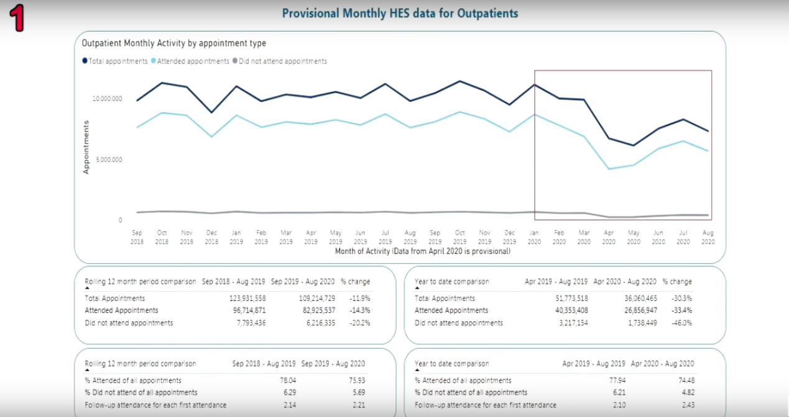
#2. As you can see in admitted patient care, the official NHS data shows that hospital admissions began to decline from the start of January 2020. The biggest and most noticeable dip was from March to April 2020, with a steady rise in admissions after that, but still well below normal levels.
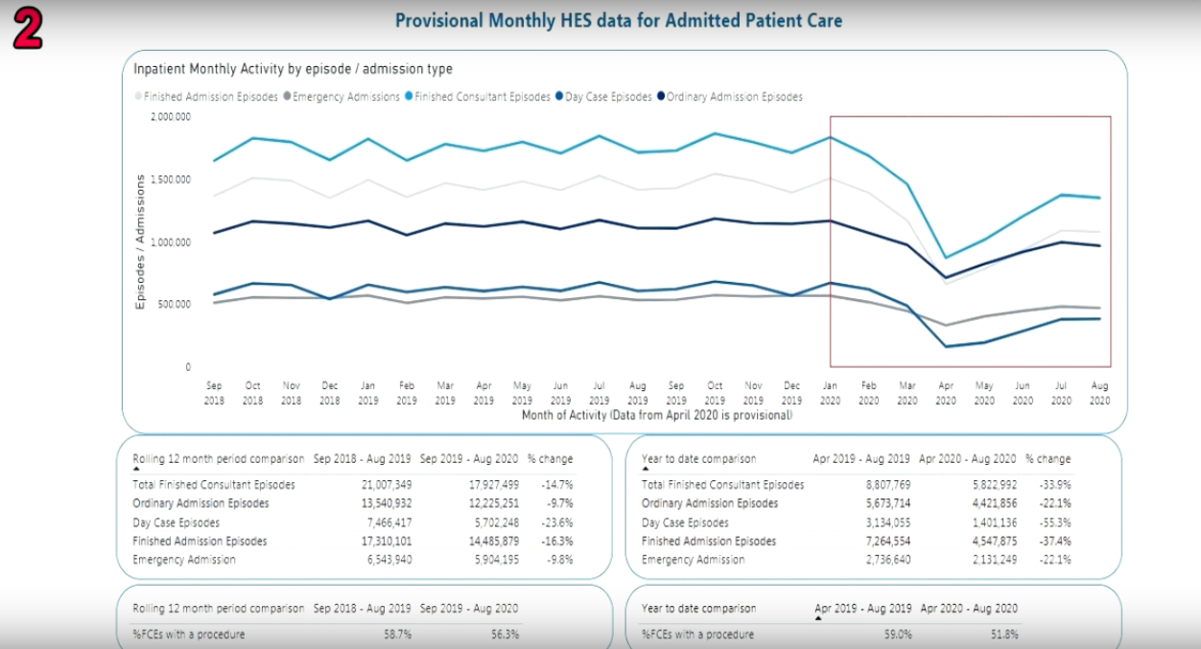
#3. NHS total emergency admissions for Jan 2018 to Sept 2020 also shows a huge downward trend from January 2020. Accident & Emergency admissions fell sharply from Jan all the way until April 2020 when it began to rise, but once again, these fell well below normal levels.
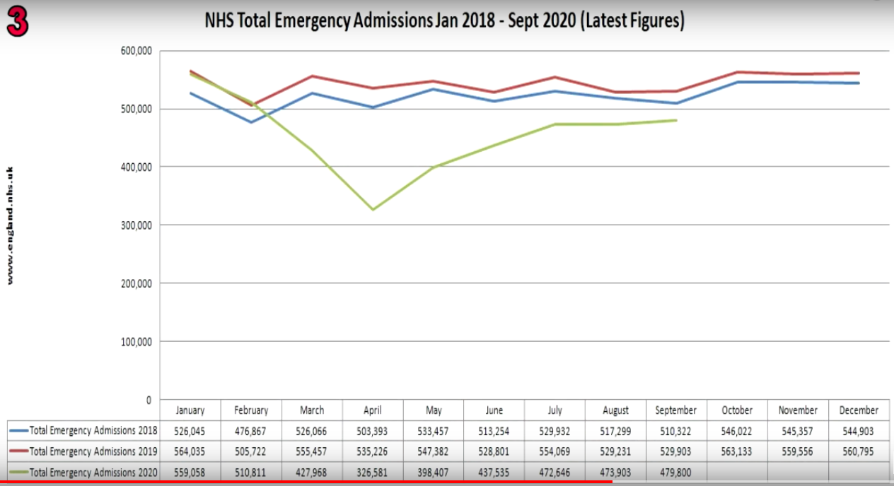
#4. Accident & Emergency attendances from Jan 2018 to Sept 2020 also makes interesting viewing. As seen in previous data the attendances fell sharply from Jan to April 2020, rose after April 2020, but still remained well below normal levels.
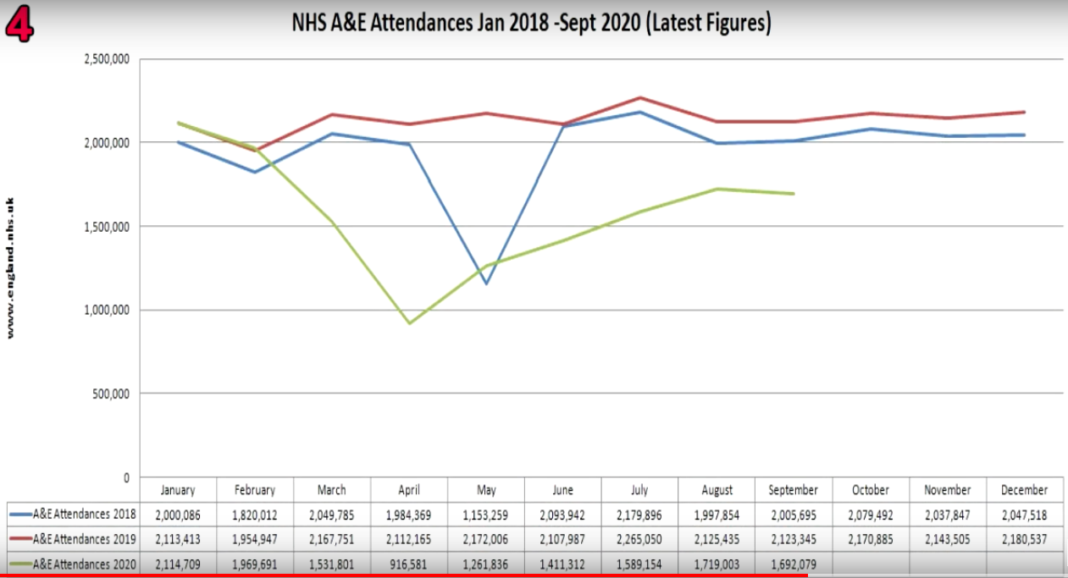
#5. ONS data for this graph changed after this version. The newer versions on ONS gives different data, so this is the last one of its type for Deaths Registered by Week for all Deaths, Average, Influenza, and Pneumonia, along with Covid-19. As you can see, Covid-19 fell below Influenza and Pneumonia from 19 June 2020 and stayed that way throughout Oct 2020, when it began to rise slightly.
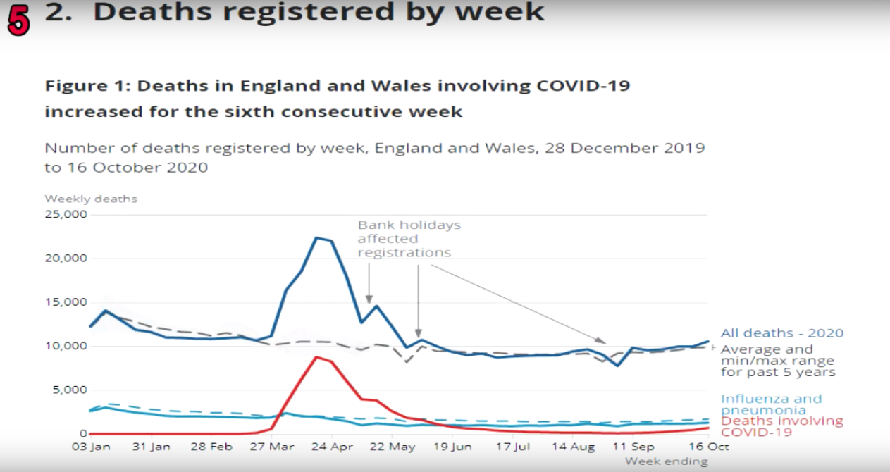
#6. In the final graph, the Monthly Figures for Deaths in England and Wales, you can see that apart from two months in 2020 (April and May) all other months are normal. Is the reason for the higher death figures in April and May 2020 due to people not going to hospital during these months to get the care they needed? Did they ultimately pay for this with their lives?
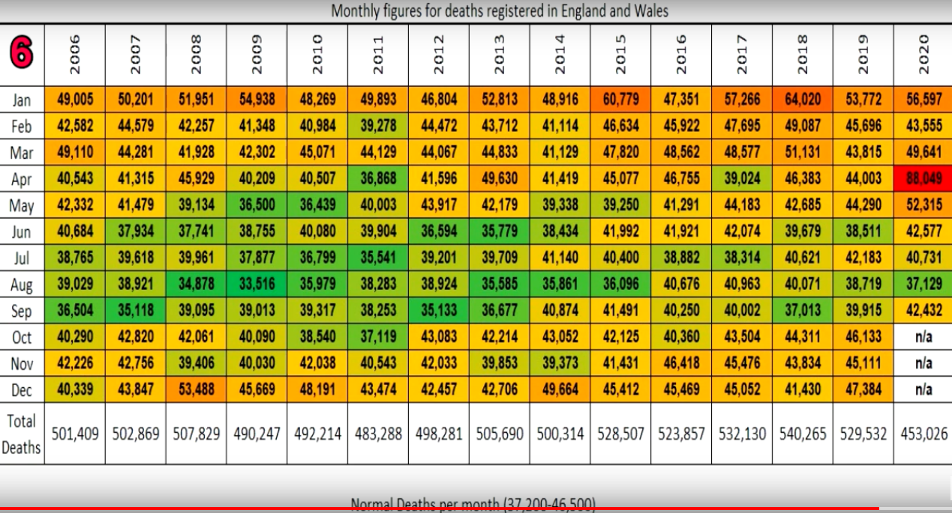
There never was an overwhelming need to ‘stay at home, protect the NHS and save lives’, because the numbers are normal. The lie continues even today through the official mainstream media and any speech against this is heavily censored by the Governments censorship department (12 separate entities). The UK citizens have been lied to and manipulated through fear and this is the criminal act of malfeasance in the public office, and yet the lie continues with the psychological fear and propaganda of asymptomatic spread. This is a very weak theory, and so many people are perpetrating this lie. Tell the truth. Stop the genocide. Protect people. Will it take the loss of one of your loved ones to remove this blindless and callousness to fulfil your duty of care?

It is common knowledge that a RT-PCR test that is running an amplification cycle of more than 36 will seek out any matter and bring forth a ‘positive’ result, which is counted as a ‘case’. The NHS are using an amplification cycle of 45, and I would question all of the data that has been used to lockdown the UK and destroy thousands upon thousands of small businesses and industries.
file:///C:/Users/hel_9/AppData/Local/Temp/guidance-and-sop-covid-19-virus-testing-in-nhs-laboratories-v1-16-march.pdf.

Video evidence: https://www.bitchute.com/video/feU1Wh1mSdgY/

This is entirely fraudulent to manipulate the UK citizens by misrepresenting data and using it to purposely crash the economy with vast amounts of taxpayers money being put toward testing. Even its inventor Kary Mullis says that PCR is not a tool for diagnosis.
https://web.archive.org/web/20210121170101/https://www.who.int/news/item/14-12-2020-who-information-notice-for-ivd-users

“…If you get a cycle threshold of 35 or more…the chances of it being replication-competent are miniscule…you almost never can culture virus from a 37 threshold cycle…even 36…it’s just dead nucleoids, period.” – Dr Anthony Fauci

Millions of people have been tested for Covid-19, and millions are still encouraged to get tested every week influenced by the Rockefeller Foundation National Covid-19 Testing Action Plan.
https://www.rockefellerfoundation.org/wp-content/uploads/2020/04/TheRockefellerFoundation_WhitePaper_Covid19_4_22_2020.pdf.

A Portuguese appeals court has ruled that PCR tests are unreliable and that it is unlawful to quarantine people based solely on a PCR test.

The court stated, the test’s reliability depends on the number of cycles used and the viral load present. Citing Jaafar et al. 2020, the court concludes that:

if someone is tested by PCR as positive when a threshold of 35 cycles or higher is used (as is the rule in most laboratories in Europe and the US), the probability that said person is infected is less than 3%, and the probability that said result is a false positive is 97%.
https://medicalkidnap.com/2020/11/18/portuguese-court-rules-pcr-tests-as-unreliable-unlawful-to-quarantine-people/

Governments and the councils are encouraging testing testing testing for Covid-19, but are you aware that the current PCR cycles that are in place by the NHS are 45 cycles. According to Dr Anthony Fauci, any cycle threshold over 36 cycles will produce data that is fallible, and yet our UK Government has been committing fraud from day one with the lockdowns, because Covid-19 was classified as no longer a high consequence infectious disease from 19 March 2020, and yet Boris Johnson put the UK into full lockdown on 23 March 2020. Why then the masks, if this virus is no longer infectious? The UK Citizens are being lied to and this is criminal activity and the persons perpetuating this lie must be held to account.
https://www.gov.uk/guidance/high-consequence-infectious-diseases-hcid#status-of-covid-19

All of the lockdowns are based on this current testing system, which relies on PCR, and so much harm is being done to families, businesses through fear and propaganda. Hundreds of thousands of public officers, including the police, military, NHS, doctors, paramedics, council staff, employers and employees are committing the tort of nonfeasance in public office and could be held liable for injuries that result in monetary losses, mental illness, and even death for members of families who have unnecessarily lost their lives. Boris Johnson, Matt Hancock, Chris Whitty, Nicola Sturgeon, Patrick Vallance, MPs, House of Lords members have committed, and are continuing to commit malfeasance in public office in continuing these lockdowns, social distancing, mask, mandates, dividing families, and OCD hand sanitising / washing based on an unreliable testing system called PCR, and all to increase the uptake of an experimental biotechnological medicines improperly labelled as ‘vaccines’. You might want to investigate those in Government who have a conflict of interest in these vaccines, as they stand to become very wealthy, so why would they not want to push these ‘vaccines’. Whatever the amount of deaths that occur from them, the vaccine manufacturers are not being held liable for injury or death.

Psychological fear and lying propaganda is everywhere, and the face masks have no science behind them, but much scientific data to prove that they cause more harm than prevent. Forcing masks upon people and a workforce is nonfeasance because there is always a duty of care to protect the health of the people and not cause harm, and employers must do the same, and yet no actual research is being carried out by them, which is the tort of nonfeasance. Employers and staff mandating the mask policies are just following the advice of the Government, and should this truth ever come out (which I believe it will very soon), a lot of compensation may have to be paid out for these injuries.

The masks also cause permanent neurological damage, and if our Governments were aware of this at the time of mandating the masks, they are guilty of malfeasance in the public office and must be prosecuted in a criminal court. The mandates on the masks were all fear-based to ensure the uptake of the Covid-19 vaccines. Employers have a duty of care to protect their people. An incredible amount of harm is being perpetuated upon the UK Citizens and this is criminal behaviour and must be stopped immediately.
VARIOUS FACE MASK STUDIES PROVE THEIR INEFFECTIVENESS PDF.pdf

Since Governments, police, doctors and nurses, and those in positions of power, which must protect the UK citizens, are failing to do so, but instead pushing an agenda of genocide under the disguise of a ‘deadly virus’ that is no more dangerous than the common flu with 99.97 percent of people SURVIVING, you are in breach of the Nuremberg code, and there must be Nuremberg trials within the 21st century to bring to account those who are causing such unnecessary sufferings, and premature deaths through this fear driven agenda.
http://www.cirp.org/library/ethics/nuremberg/

You are identified as a key player in this genocidal agenda and we the people, whom you serve, require action, honesty, an immediate cessation of this experimental genetic engineering vaccine programme and require independent scientific proof for everything that has unfolded over the past year.

We also require of you reparations for the unnecessary damage caused to small businesses and livelihoods as a result of the lockdowns, and to hold doctors who have committed fraud in declaring that deaths were of Covid-19, when they were caused by existing health conditions. An official apology must be made to all families who have suffered unnecessary loss because of the lockdowns, and the current biotechnological medicine vaccines, plus damages paid for these torts. The agency you represent has played a prominent part in the rollout of the ‘vaccination’ programme. Simply following orders is no excuse. We demand an immediate cessation to this vaccine trial upon the UK citizens, and for Hydroxychloroquine to be administered at the relevant low doses to those with real Covid-19 infections. The fact that the scientific publication Lancet had to smear a cheap and effective anti-malaria drug is to commit malfeasance in the public office and carries with it a prison sentence, because this was done with intent and purpose to suppress a life-saving treatment in favour of an expensive risky vaccine, and many could have been saved who have unnecessarily died. This is purposeful genocide.
https://soundcloud.com/onlyjesussaves/whitecoat-medical-summit-the-cure-for-covid-19

Several class action lawsuits have begun against various non-governmental bodies in relation to these Covid-19 restrictions which relies on the fallible PCR data and causing undue damage worldwide, and it is only a matter of time until all public officials who have acted in wilful ignorance, or purposefully, will be held accountable for misfeasance, malfeasance, or nonfeasance. Do the right thing while you still can. #

This world system is fallible. One day this Babylon world system will be destroyed, and was it worth it to continue to lie to the UK citizens? You may get away with these crimes through the corrupt bought judicial court system, which if bribes are taking place is the criminal act of malfeasance, and money may take you so far.

ALL life is precious to Almighty God, and those in positions of power who are using taxpayers money to push their own agendas will be held accountable one day, either at the Judgement Seat of Christ, as a believer in Jesus as Saviour, or at the Great White Throne Judgement where they will get the level of punishment that they deserve. Satan is already using masses of people to push this false climate change agenda to ‘save the planet’ which is just more lying policies to extract wealth from the poor to the wealthy. The virus is the excuse for a ‘great reset’. You are taking part in this agenda if you are pushing these Covid-19 restrictions via the psychological warfare and lies. Are you aware that one sin is enough to send a person to hell? Hasn’t Satan been busy this past year using lies and deceit, causing divide amongst humanity, without these people even considering the wrongs that they commit. This is WHY we need a Saviour, and it is why Jesus came. Works can save no one. They are as filthy rags before a Holy God (Isaiah 64:6). We must be born again in the family of God.

And there shall in no wise enter into it any thing that defileth, neither whatsoever worketh abomination, or maketh a lie: but they which are written in the Lamb’s book of life – Revelation 21:27
It is not too late to see your need for a Saviour in Jesus Christ. He is the only way. There is a 7-year tribulation that will come upon this earth, a time of God’s wrath, supernatural demonic activity, but you can still be saved, as God is merciful and longsuffering and wants none to perish, but have a change of mind about what God has done for humanity in sending Jesus to die for us a death that we all deserve. He was buried and rose again on the third day proving that salvation is available to all those that trust in Him alone. Time is short. The one world religion is being prepared through the Roman Catholic Church, a religion that deceives many, but there will be 144,000 Jewish witnesses who will proclaim the truth of Christ to a lost dying world.
I plead with you to get on the right side of humanity and trust in Jesus Christ as your Saviour today, because tomorrow is promised to no-one. Time is short if this is God’s will for that one world system to develop to make way for the antichrist / beast political leader of Revelation 13. Many many people will believe him to be God and be deceived by taking a mark in the forehead or right hand. I hope that you change your mind before it is too late.
If you do become a whistle-blower that helps humanity in these troubling satanic times, these works can only be pleasing to Almighty God through the new resurrected nature, the indwelt imputation of the very righteousness of God Himself through the Lord Jesus Christ, which you receive when you put your trust in his finished work of Christ by his death, burial and resurrection. No amount of human works can bring salvation, because salvation is a gift of God bought and paid for by the blood of Jesus Christ. This has been the deception of Satan all along through religions of various names. They all believe that good works will earn them heaven, but the biblical truth is that it is by grace alone, through faith alone in Christ alone. The way to heaven is exclusive and it is through the work of Jesus Christ, the perfect God-Man.
Lying can only take you so far, but when you are hurting so many people in favour of purposely crashing the economy to allow Non-Governmental Organisations to forward their agenda for a great reset sustainable planet, you are hurting only yourself and your eternal soul. Today is the day to face the reality that you cannot win because you are on the side of the adversary the devil, and Jesus Christ defeated Him on the cross when he rose from the dead. His time is short, and He is using you to accomplish his plan for world dominion, but Babylon will fall, will fall.
Yours sincerely,

Your name

